Artificial Intelligence Project Documentation
Project Title:
Motivational Quotes Chatbot

Submitted by
Syeda Muqaddas Rizwan (37508)
Bibi Masooma (37771)
Submitted to
Ma’am Tayyaba
Date:
28 Nov 2025

1. Introduction
The Motivational Chatbot is a simple AI-based application designed to provide motivational and positive responses to users. When a user expresses an emotion such as sadness, stress, or lack of motivation, the chatbot replies with supportive and encouraging messages. The system is built using Python, Tkinter for GUI, and a JSON file as the database.

2. Objectives
- To create a chatbot that provides motivational responses.
- To use Python and Tkinter to build a user-friendly interface.
- To store and retrieve responses using a JSON dataset.
- To motivate users by responding to emotional or motivational queries.

3. Tools & Technologies
- Python
- Tkinter (GUI)
- JSON (dataset storage)
- Libraries: json, random, tkinter

4. Methodology
- A dataset of motivational inputs and responses was created in a JSON file.
- The program reads user input and matches it with questions from the JSON file.
- A random motivational reply is displayed from the matching category.
- A GUI interface allows users to chat with the bot in real time.

5. Features
- Simple and attractive Tkinter chat interface
- More than 100 questions and hundreds of motivational replies
- Randomized responses for variety
- Goodbye message ("bye") for exit
- Emotion-based keywords such as sad, tired, stressed, unmotivated

6. Conclusion
The Motivational Chatbot successfully delivers positive messages to help users feel better. It is easy to use, interactive, and demonstrates practical concepts of Python programming, GUI development, and basic AI logic. The project can be improved in the future by adding NLP, voice features, or more advanced emotional understanding.
Code:
import tkinter as tk
from tkinter import scrolledtext
import json
import random

# Load questions and answers from JSON
with open("questions.json", "r") as file:
questions_data = json.load(file)

# Function to get answer based on user input
def get_answer(user_msg):
user_msg = user_msg.lower()
for item in questions_data:
if item["question"].lower() == user_msg:
return random.choice(item["answers"])
return "Keep going! Stay motivated!"

# Function to handle sending messages
def send_message(event=None):
user_msg = user_input.get()
if not user_msg.strip():
return
chat_area.config(state='normal')
chat_area.insert(tk.END, f"You: {user_msg}\n")
if user_msg.lower() == "bye":
chat_area.insert(tk.END, "Motivational Chatbot: Bye! Stay motivated!\n")
chat_area.config(state='disabled')
window.after(1000, window.destroy)
else:
bot_reply = get_answer(user_msg)
chat_area.insert(tk.END, f"Motivational Chatbot: {bot_reply}\n\n")
chat_area.config(state='disabled')
chat_area.yview(tk.END)
user_input.delete(0, tk.END)

# GUI setup
window = tk.Tk()
window.title("Motivational Chatbot ")
window.geometry("500x500")

chat_area = scrolledtext.ScrolledText(window, wrap=tk.WORD, state='disabled')
chat_area.pack(padx=10, pady=10, fill=tk.BOTH, expand=True)

user_input = tk.Entry(window, font=("Arial", 14))
user_input.pack(padx=10, pady=10, fill=tk.X)
user_input.bind("<Return>", send_message)

send_button = tk.Button(window, text="Send", command=send_message)
send_button.pack(padx=10, pady=5)

# Welcome message
chat_area.config(state='normal')
chat_area.insert(tk.END, "🤖 Motivational Chatbot: Hi! I'm here to motivate you. Type 'bye' to exit.\n")
chat_area.insert(tk.END, "✨ Motivational Chatbot ✨\n\n")
chat_area.config(state='disabled')

window.mainloop()

question.Json:
[
{"question": "hello", "answers": ["Keep going, you are doing great!", "Stay positive, better days ahead."]},
{"question": "i feel tired", "answers": ["Rest now, regain your strength.", "Slow down and breathe deeply."]},
{"question": "i feel sad", "answers": ["Brighter days are coming soon.", "Your feelings will get lighter."]},
{"question": "i feel stressed", "answers": ["Relax, everything will be okay.", "Take a moment to breathe."]},
{"question": "i feel worried", "answers": ["Stay calm, everything will settle.", "Let go, things will improve."]},
{"question": "i feel lazy", "answers": ["Small steps create big progress.", "Start small, build your momentum."]},
{"question": "i feel unmotivated", "answers": ["A fresh start begins now.", "Do one small thing today."]},
{"question": "i feel weak", "answers": ["Strength grows with every struggle.", "You are stronger than you think."]},
{"question": "i feel confused", "answers": ["Clarity will come with time.", "Slow down and refocus calmly."]},
{"question": "i feel alone", "answers": ["You are never truly alone.", "Someone cares more than you know."]},
{"question": "i feel angry", "answers": ["Breathe before you react now.", "Calm comes with steady patience."]},
{"question": "i feel bored", "answers": ["Try something new today.", "A new idea brings energy."]},
{"question": "i feel scared", "answers": ["Courage grows in small steps.", "Fear fades when you act."]},
{"question": "i feel low", "answers": ["This moment will pass soon.", "Your spirit will rise again."]},
{"question": "i feel hopeless", "answers": ["Hope always returns with time.", "Better days are ahead."]},
{"question": "i feel anxious", "answers": ["Deep breaths calm your mind.", "You are safe right now."]},
{"question": "i feel down", "answers": ["Stand up slowly and breathe.", "You will feel better soon."]},
{"question": "i feel stuck", "answers": ["One small action breaks stuckness.", "Movement begins with tiny steps."]},
{"question": "i feel lost", "answers": ["Your direction will appear soon.", "Trust yourself, you'll figure out."]},
{"question": "i feel nervous", "answers": ["Nerves show you truly care.", "You can handle this moment."]},
{"question": "i feel useless", "answers": ["You matter more than you think.", "Your actions have real value."]},
{"question": "i feel pressure", "answers": ["Pressure builds strong character.", "You can manage this challenge."]},
{"question": "i feel lonely", "answers": ["Reach out, connection brings peace.", "Someone cares about you deeply."]},
{"question": "i feel empty", "answers": ["Fill your day with calm.", "Moments like this will pass."]},
{"question": "i feel defeated", "answers": ["Stand again, you are strong.", "Every setback is temporary."]},
{"question": "i feel depressed", "answers": ["You deserve peace and comfort.", "This pain will not stay."]},
{"question": "i feel overwhelmed", "answers": ["Do one thing at once.", "Take things slowly and breathe."]},
{"question": "i feel disappointed", "answers": ["Better opportunities will come again.", "Things will get better soon."]},
{"question": "i feel broken", "answers": ["Healing starts with small steps.", "You will feel whole again."]},
{"question": "i feel stuck in life", "answers": ["Start with one small change.", "New paths appear over time."]},
{"question": "i feel uncomfortable", "answers": ["Growth begins in discomfort often.", "This feeling will fade soon."]},
{"question": "i feel drained", "answers": ["Recharge and rest your mind.", "Your energy will return."]},
{"question": "i feel frustrated", "answers": ["Pause and breathe deeply now.", "Frustration fades with patience."]},
{"question": "i feel nervous about exam", "answers": ["You prepared more than enough.", "Stay calm, you will pass."]},
{"question": "i feel anxious about future", "answers": ["Focus on today, not tomorrow.", "Future becomes clear with time."]},
{"question": "i feel embarrassed", "answers": ["Everyone makes mistakes sometimes.", "This moment will be forgotten."]},
{"question": "i feel discouraged", "answers": ["Try again with fresh energy.", "You are capable of more."]},
{"question": "i feel jealous", "answers": ["Focus on your own journey.", "Your time will come soon."]},
{"question": "i feel ashamed", "answers": ["Forgive yourself, grow forward.", "You deserve kindness too."]},
{"question": "i feel nervous to start", "answers": ["Beginnings are always scary.", "Start small and keep going."]},
{"question": "i want success", "answers": ["Stay focused and work consistently.", "Small progress leads to success."]},
{"question": "i want confidence", "answers": ["Believe slowly in your abilities.", "Confidence grows with daily effort."]},
{"question": "i want motivation", "answers": ["You already have inner strength.", "Start with one simple action."]},
{"question": "i want peace", "answers": ["Choose calm in small moments.", "Peace starts inside your mind."]},
{"question": "i want happiness", "answers": ["Happiness grows from small things.", "Find joy in simple moments."]},
{"question": "i want strength", "answers": ["Strength builds slowly every day.", "You become stronger by trying."]},
{"question": "i want to study", "answers": ["Study in small focused sessions.", "Start now with one chapter."]},
{"question": "i want to improve", "answers": ["Daily effort brings improvement.", "Keep trying and stay consistent."]},
{"question": "i want inspiration", "answers": ["Look around, inspiration is everywhere.", "You are your own inspiration."]},
{"question": "i want guidance", "answers": ["Listen to your inner wisdom.", "Trust the direction you choose."]},
{"question": "life is hard", "answers": ["Hard times make you stronger.", "You will rise from this."]},
{"question": "life feels empty", "answers": ["Fill it with meaningful moments.", "Small joys rebuild your heart."]},
{"question": "life feels unfair", "answers": ["Better days always come later.", "You will overcome this phase."]},
{"question": "life feels confusing", "answers": ["Clarity comes step by step.", "Everything will make sense later."]},
{"question": "life is stressful", "answers": ["Pause and breathe deeply now.", "Take things one moment at time."]},
{"question": "i feel like giving up", "answers": ["You’ve come too far already.", "Hold on, better days coming."]},
{"question": "i feel no one cares", "answers": ["You matter more than you know.", "Someone is grateful for you."]},
{"question": "i feel nothing", "answers": ["Numbness fades with time.", "You will feel again soon."]},
{"question": "i feel dissatisfied", "answers": ["Work slowly toward improvement.", "Small changes bring big results."]},
{"question": "i feel mentally tired", "answers": ["Give your mind gentle rest.", "Pause and reset your thoughts."]},
{"question": "i want encouragement", "answers": ["You are capable of greatness.", "Keep believing in yourself always."]},
{"question": "i want positivity", "answers": ["Focus on what feels good.", "Shift your thoughts toward light."]},
{"question": "i want hope", "answers": ["Hope grows in small steps.", "Better days are approaching soon."]},
{"question": "i want clarity", "answers": ["Take time and reflect calmly.", "Answers come when mind settles."]},
{"question": "i want discipline", "answers": ["Start small and stay consistent.", "Discipline builds through routine."]},
{"question": "i am confused", "answers": ["Take one decision at time.", "Clarity grows as you act."]},
{"question": "i am stressed", "answers": ["Breathe slowly and calm down.", "Everything will work out eventually."]},
{"question": "i am losing focus", "answers": ["Refocus with short break now.", "Start again with fresh mind."]},
{"question": "i am scared to fail", "answers": ["Failing teaches important lessons.", "Every failure moves you forward."]},
{"question": "i am sad today", "answers": ["Let yourself feel gently today.", "Sad days don’t last forever."]},
{"question": "i can't study", "answers": ["Start with five simple minutes.", "Break tasks into smaller steps."]},
{"question": "i can't sleep", "answers": ["Relax and slow your breathing.", "Calm thoughts help you sleep."]},
{"question": "i can't focus", "answers": ["Remove distractions, start gently.", "Take a short refreshing break."]},
{"question": "i can't think clearly", "answers": ["Pause and clear your mind.", "Step away and return refreshed."]},
{"question": "i can't decide", "answers": ["Choose the simplest next step.", "Trust your intuition and act."]},
{"question": "i need advice", "answers": ["Trust yourself and stay patient.", "One step forward is enough."]},
{"question": "i need help", "answers": ["You’re not alone, reach out.", "Asking help shows great strength."]},
{"question": "i need motivation", "answers": ["Start with one tiny action.", "Your effort will build momentum."]},
{"question": "i need confidence", "answers": ["Believe slowly in your ability.", "Confidence grows with practice daily."]},
{"question": "i need courage", "answers": ["Take brave small steps daily.", "Courage grows when you try."]},

{"question": "i am overthinking", "answers": ["Focus on what’s controllable now.", "Let unnecessary thoughts float away."]},
{"question": "i am overwhelmed", "answers": ["Do tasks one by one.", "Take small breaks between work."]},
{"question": "i am upset", "answers": ["Let emotions pass naturally now.", "You will feel lighter soon."]},
{"question": "i am frustrated", "answers": ["Slow down and breathe deeply.", "Patience will help you recover."]},
{"question": "i am disappointed", "answers": ["Better things are coming soon.", "Don't give up on yourself."]}
]
Screen Shot 1:
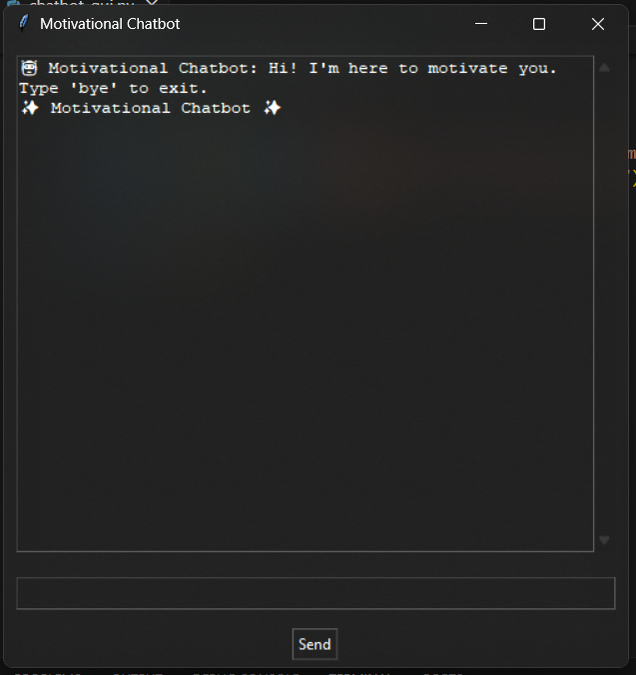

Screen Shot 2:
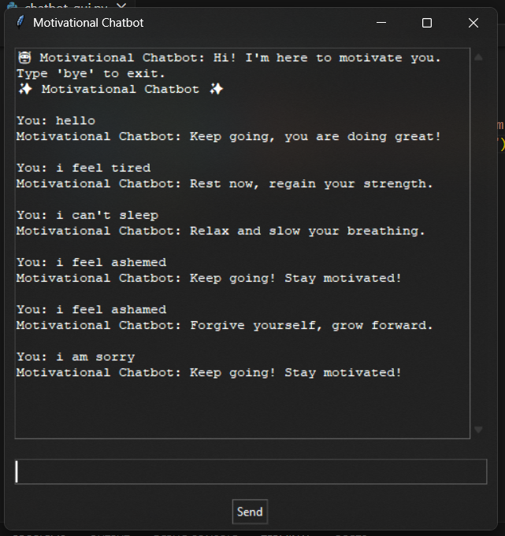
Visual Studio Screen Shot:
